# GooglePublishEventStep

**Objective:**

It is used to publish a message to the Google Publish and Subscribe service.

**Attributes:**

|  |  |
| --- | --- |
| **Attributes** | **Description** |
| topicName | Name of the topic to which the message has to be published |
| serviceAccountFileLocation | Location of the service account file |
| data | Payload which is to be published to Googles pubsub service |
| plugin_name | To connect with google publish plugin |

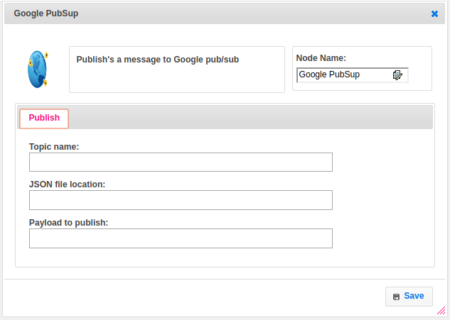

**Executor Description:**

In executor class first it requires the account JSON file to authenticate with PubSub service. This works asynchronously to publish the message. Create a publisher instance with default settings bound to the topic. Convert the message data to bytes. If there is any exception it will through. After finished with publisher it will shutdown to free up resources.